Job Title: Chief Operating Officer
Company: 64 Million Artists
Type: Permanent, Full Time (full time is a 4-day week at 100% salary).
Annual Salary: £55-60k dependent on experience
Reports to: Chief Executive Officer (COO)
Workplace: We work in person weekly on Tuesdays in Central London (currently we are based at Somerset House Exchange). The rest of the time we work from home. We require you to cover your own expenses for the weekly day in London but any other travel required will be covered by the company (for this role we anticipate very occasional UK day trips may be required).
Remote working allowance: £100 per month
Holiday: 20 days plus bank holidays, your birthday, August (company-wide 4 weeks off) and c. 4 days between 24 December and 1 January
Closing date: Monday 20th May 9am
Interviews: First round: w/c 17th June (online), Second interview 25th June (in person)
Information Webinars: Wednesday 8th May 12pm
Wednesday 15th May 9am
The webinar will be recorded and available to view subsequently on our website
Contact: damian@64millionartists.com - Damian Hebron - Interim Executive Director

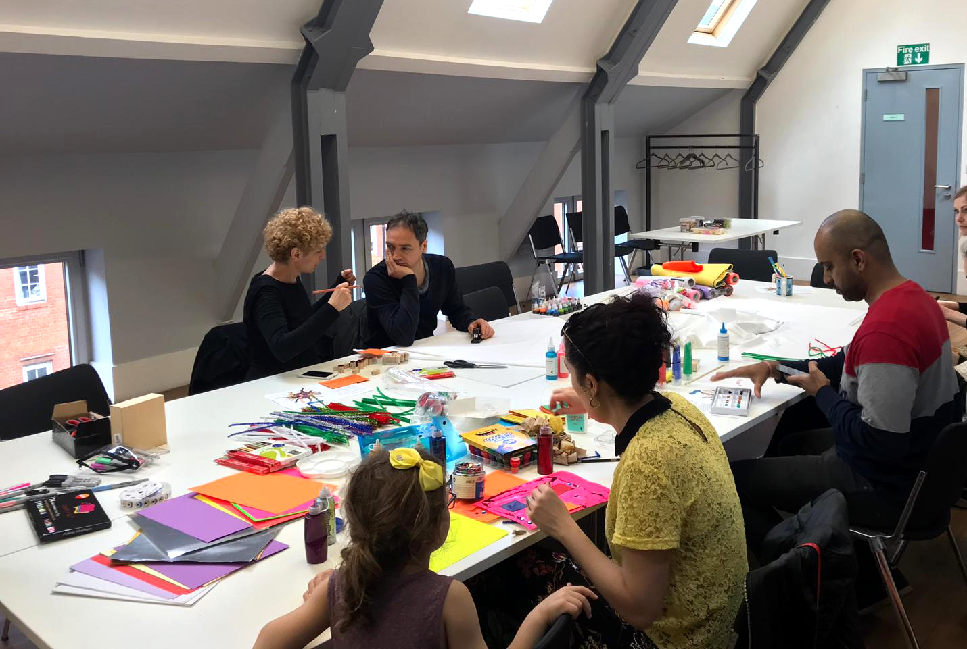
The Role
As our company grows, we are seeking an experienced leader with a passion for and commitment to care, creativity, curiosity and inclusive and effective working processes to take on this new senior role. The COO will oversee the company’s systems, finances and HR, and further build on our thriving organisational culture which is wholeheartedly person-centred and aims to allow each of our team members to thrive in their own way.

This role will work closely with the Chief Executive, managing and caring for the day to day workings of the company, supporting the staff team and maintaining/improving culture and processes. The role will continue to build on and develop effective operational systems and embed a strong company culture that meets the needs of our diverse team through what is an exciting period of continued growth for the organisation. Crucially, this role will take responsibility for leading on our efforts to ensure Equity, Diversity and Inclusion are embedded throughout our team culture and in all of the work that we do.

The role will include the following responsibilities:

- Taking overall responsibility for the wellbeing, care and culture of the team
- Leading the EDI working group and taking the lead on embedding best practice across all of our work
- Organising staff training and development
- Line managing up to 5 members of the team (a chart showing the organisational structure can be found here)
- Overseeing financial processes and systems, managing cashflow and income generation (annual turnover is c.£750,000) (with the support of our Financial Administration Partner- Beehive)
- Supporting income generation, including fundraising bids, pitching for new business, etc
- Overseeing all policies and systems to support the day-to-day functioning of the team
- Overseeing our research and evaluation processes, impact reporting and reporting to funders (with the support of our Research Partner - Tialt)
- Working with the CEO on company strategy and business planning
- Working with the CEO to ensure staffing and other resources are aligned with company strategy and business plan, ensuring clarity for staff on areas of responsibility
- Leading on internal communications to ensure staff are best able to understand organisational priorities and vision
- Ensure HR policies and procedures are effectively communicated to staff, adhered to and kept up to date (with the support of our HR Partner - HR Active)
- Oversee IT and administrative systems ensuring they are effective, resilient and good value for money
- Maintaining effective governance: supporting the Board of Directors and organising meetings and away days
- Deputising for the CEO when necessary

Skills and experience
We are keen to build a diverse team, so there is no single route you will need to have taken to apply for this role. You may never have worked in a creative company before, though you will have a commitment to our values of care, belonging, courage and curiosity; and be someone that can work autonomously and as part of a team. These skills may have been built in a range of professional roles but also through personal experiences like caring, volunteering or leisure activities.

We are trying to build a team reflective of a wide range of experiences, backgrounds and personalities to ensure the best possible team to support the organisation. We are actively encouraging applications from people from the Global majority (People of Colour) and d/Deaf and Disabled applicants as these are growing areas of our network. We are also open to flexibility in working arrangements if these can be made to work with the demands of the role.

Essential
- Demonstrable commitment to Equity, Diversity, and Inclusion and experience of integrating EDI ambitions into programmes and ways of working
- Knowledge and passion for developing cultures of care within teams
- Experience of working in a senior strategic role including business planning and implementation.
- Experience of managing diverse teams or groups
- Experience of overseeing operations, policies and systems
- Experience of being responsible for and managing large budgets
- Strong communication (written and oral) and interpersonal skills, being an approachable team player who enjoys working in a small team
- Aligned with our values

Desirable
- Interest in or experience of leading policy and research
- Experience of fundraising
- Experience of change management
- Experience of delivering project management systems for remote working
- Knowledge of the wider cultural sector
- Strong understanding of HR processes
- Experience of governance and not for profit organisations

About us
At 64 Million Artists we believe that everyone is creative and that when we are creative we can make positive change in our lives and in the world around us. Over the last 10 years we have mainly been working in 4 key areas:

Public Programmes
We run free, UK-wide online programmes like The January Challenge and The Weekly Challenge to kickstart creativity and wellbeing. Over 160,000 participants took part in The January Challenge this year, either as individuals, or in school groups, youth and community groups, hospital settings, workplaces and families. We also develop and share free packs and resources to inspire thousands of creativity champions across the UK to run their own creative activities and be part of a supportive community.

Leadership Programmes
We facilitate culture change through creativity. Our bespoke support benefits clients such as King’s College London, University of Edinburgh, University of Manchester and several other Russell Group universities. We also run leadership work across communities, workplaces and educational establishments. Our aim is to embed creativity in new settings and leave a legacy by empowering leaders to then go on to train and develop others.

Partnership Programmes
With our partners, we co-create programmes for positive change by activating everyone’s creativity. Many of these are based in local communities. We’ve worked with Leicester Ageing Together on social isolation and creative ageing, YoungMinds on mental health, and Coventry 2021 on citizen-led culture. We’ve also worked with local authorities in Gateshead, Cumbria, Crewe, several London Boroughs, and Hull during their City of Culture year in 2017. In 2024, we launched a new Creative Courage programme - a paid online personal development journey, enabling people to explore and develop their own creative solutions to personal challenges.

Policy & Research
We collaborate with academic partners such as King’s College London and UCL, and development agencies such as Arts Council England and Arts Council Wales to undertake research into key issues around everyday creativity. We have contributed to national policy in the area and are included in a range of broader research publications from organisations such as Baring Foundation, Culture Health and Wellbeing Alliance and the Centre for Cultural Value. This is an area of our work we are keen to grow and develop.

Application process
Please fill in the online Application Form and Equal Opportunities Form by 9am Monday 20th May. Please do not send CVs because we anonymise candidates and ask application questions to minimise unconscious bias in the process.

Interviews will be through a two stage process. An initial group of candidates will be invited to attend an online interview in the week commencing 17th June . A shortlist of candidates will then be invited to an in person interview where they will meet members of the 64 Million Artists team, in person on 25th June (candidates invited to this second stage will be paid for travel and a small honorarium for their time). Please advise us in your application if you are unavailable on these dates for any reason and we will do our best to accommodate.

If you would be helped by any reasonable adjustments to our application process, please don’t hesitate to contact Damian@64millionartists.com .

We will be running 2 Zoom webinars to help people to find out more about the job and to answer any questions people might have. These will take place on:

Wednesday 8th May 12pm
Wednesday 15th May 9am

