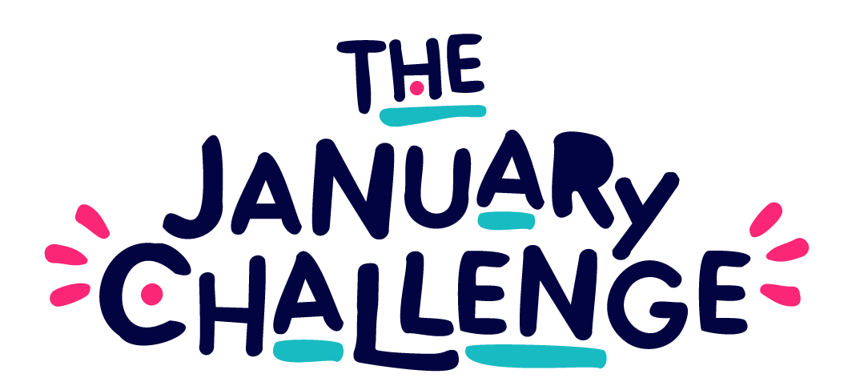

Are you a Creativity Champion?
64 Million Artists is recruiting a cohort of Creativity Champions to support the delivery of The January Challenge 2025. The application Form is linked at the end of this document (page 6).
Role: Creativity Champion for The January Challenge 2025
Time scale: 12 Days, July 2024 - July 2025
Fee: £3,000
Application deadline: Sunday 2nd June 8pm
We are hosting an information session on Wednesday, May 15th, at 12.30 pm GMT, where you can ask any questions about the Creativity Champion role and The January Challenge.
Register to attend here.

What is The January Challenge?
The January Challenge is a national campaign for creativity and wellbeing by 64 Million Artists - 31 days of fun, accessible prompts designed to spark your imagination! Each prompt invites you to 'do, think, and share' – get creative, reflect on your experience, and share in a way that's meaningful to you. The prompts are designed by people, community groups and organisations from across the UK. They explore anything (and everything!) from writing, making, exploring and movement. Find past examples here.
Over 160,000 people worldwide participated in The January Challenge 2024, experiencing joy, connection, and personal growth. In fact, 93% of participants reported a positive impact on their wellbeing. You can read more about the 2024 campaign here.

What is a Creativity Champion?
We know that creativity thrives within community spaces (at work, home, or localised groups) when the right conditions are nurtured; people have a sense of agency, there is access to resources, and a culture of inclusion. We call the facilitators of these conditions Creativity Champions. Creativity Champions are people working in a range of community settings; they are librarians, arts-coordinators in prisons, hospitals and care homes, cultural sector workers, community group and team leaders. Our programmes support Creativity Champions and their wellbeing, whilst also developing their practice to grow impact in their communities.
Creativity Champions will invite others to participate in The January Challenge and create opportunities for people to get creative together. They might establish new groups or introduce the Challenge to groups or communities they are already a part of. The activity can be delivered in any language, including British Sign Language, and all January Challenge materials will be available in the Welsh Language. We can also offer translation services into Polish, Urdu or Punjabi. The group you work with might be:
- A community connected by place (at work, or home)
- A community connected by lived experience
- A community connected by shared interest
Click here for more from the 64 Million Artists team, on what it means to be a Creativity Champion.

Why?
Our data tells us that The January Challenge can build a sense of community and connection in groups, boost wellbeing and inspire people to keep on using their creativity for positive change. The January Challenge is for everyone - and - we know that targeting ‘everyone’ disregards barriers to participation.
Tailored spaces built for specific audiences can support people to become and stay involved. We hope to be led by Champions who are embedded in different community settings, and work with them to take The January Challenge and bring it to life in different places.

What's happened before?
In 2024, the creative prompts were designed by 31 brilliant people, community groups and organisations. You can meet them by clicking here.
Together, we hosted and co-hosted 30 events, training sessions and workshops, with over 1,700 people coming along and taking part.
Events happened online, and in venues and spaces across England, Scotland, Wales, Northern Ireland. We created zines with Lea Cooper in Kirkcaldy, made stop-motion animation in Belfast with BlackBox, explored the forests of Llanrwst with Sian Wiliams, and made music with NEONE the Wonderer in Wolverhampton.
Ava Riby-Williams hosted a singing circle and Pan African celebration, Nathan Mann hosted a script-writing workshop for people with Autism and Zesty’s Collective hosted several Queer Crafternoons in Nottingham. 64 really went on tour!
Watch a snippet of highlights from the The January Challenge 2024 here.
We don't know yet what will happen in 2025 - because we want this to be shaped by the interests of our future Creativity Champions…

Everything you need to know
Payment and role expectations:
The ideal applicant for this role is somebody who is motivated to establish or develop a group, using creative prompts to connect and build community. The role is an opportunity to develop your own skills as a Creativity Champion, be a part of a cohort with others and to invest time and energy into pursuing an idea or area of interest you have.

You will be paid £3,000 for 12 days of your time between July 2024 - July 2025, which will include:
- Designing 3 of the 31 creative prompts that will become a part of The January Challenge campaign (supported by 64 Million Artists).
- Develop and host a creative group and support the group to take part in The January Challenge. This work includes developing marketing materials, establishing a space to share and connect and seeking opportunities to spread the word!
- Further to your work with your group, we will work together to host one event open to the public during January (this might be an in person workshop, a talk online, a panel event, etc - and we will work with you to make sure it feels appropriate and relevant to you and your work)
- Attend the following In-Person Sessions (these will take place in London and travel expenses will be covered):
- Wednesday 17th July 2024 - Kick Off and Welcome Day
- Wednesday 18th September 2024 - Training and Support Day
- Wednesday 16th October 2024 - Training and Support Day
- Wednesday 19th February 2025 - Reflection and Feedback Day
- Thursday 17th July 2025 - Check In and Reflections (½ Day)
On the training and support days, we will cover; safeguarding, creative facilitation, marketing your idea, and access and inclusion principles. We will also explore creative ways to embed impact measurement into your work with your group and how you can embed reflection & learning across the process. These days will also be an opportunity for 1-2-1 and peer to peer support.
64 Million Artists will support you with:
- Ongoing 1-2-1 online sessions to establish clear boundaries around what you would like to do and what support you might need to do it.
- A sharing forum for the cohort to connect with and support each other
- Access to The January Challenge Champions Pack 2024 (available in English and Welsh), including the challenges ahead of time, and optional session plans
- Additional expenses you might incur whilst hosting activity, including room hire, snacks, travel and access costs
- Access support and cost covered wherever required
We work responsively, and will always endeavour to support you to feel safe and comfortable in the role.

Access
Access is a fundamental component of The January Challenge and all of the groups, events and workshops that happen alongside it. We will work with you to identify the right support for both your involvement as a Creativity Champion and for your group.

FAQ’s
How many Creativity Champions are you recruiting?
From this application process we will be recruiting five Champions.

What expenses will be paid in addition to the £3,000 fee?
We have a budget to cover expenses for your group activity and public events such as venue, snacks, materials and access costs. For the in person days, we will cover travel costs if you are travelling from outside of London.

Is this offer only open to individuals?
No, you are welcome to apply for this opportunity as an individual or as an existing community group. Please note, if you apply together we are not able to increase the fee. Nor are we able to cover the fee of additional facilitators of your group down the line.

I’m based outside the UK, can I apply?
No, this opportunity is only open to those based in the UK: England, Scotland, Wales and Northern Ireland.

How to Apply:
Express your interest to become a Creativity Champion via this form:
Apply here. Deadline: Sunday 2nd June 2024 at 8pm.
Optional, please complete this Equal Opportunities Form.
Applicants should use the form to tell us about your ideas, how you would hope to use your time as a Champion, and why. We are looking for people who are excited about using creativity to build and connect communities - you don't have to be an experienced facilitator or have taken part in The January Challenge before.
If you have any further questions, please be in touch with us at yashoda@64millionartists.com
We are hosting an information session to ask any questions about the Creativity Champion role and The January Challenge. Wednesday 15th May at 12.30pm. Register to attend here
Timeline:
Express your interest and apply by Sunday 2nd June 2024 at 8pm.
We will be in touch by 12th June to let you know whether or not your application was successful. If successful, we will arrange a short interview with you on 17th or 18th June to hear more about your idea and what support you might need.
If successful, your time - approx 12 days, which includes the 4 and a half days in person, is yours to use how you decide once your group plans are established, though we expect that the majority of your time will be used in January.
If successful, you will be required to attend these in-person days:
- Wednesday 17th July 2024 - Kick Off and Welcome Day
- Wednesday 18th September 2024 - Training and Support Day
- Wednesday 16th October 2024 - Training and Support Day
- Wednesday 19th February 2025 - Reflection and Feedback Day
- 17th July 2025 - Check In and Reflections (½ Day)

