**Job Title:** Temporary Project Manager

**Company**: [64 Million Artists](http://www.64millionartists.com)

**Type:** Temporary, Part time - an average of 18 hours/week for about 18 weeks

**Hours:** Flexible, may be worked across the week.

**Weekly fee:** £800 (contracted Project Manager will be responsible for their own tax, NI and expenses)

**Starting:** As soon as possible (you need to be able to start before the end of July - contract is expected to run until the end of November.)

**Reports to:** Head of Leadership Programmes

**Workplace:** Remote

**Closing date:** Tuesday 9th July, 5pm

**Interviews:** Online on Thursday 11th July

**Contact:** [damian@64millionartists.com](mailto:damian@64millionartists.com) - Damian Hebron - Interim Executive Director

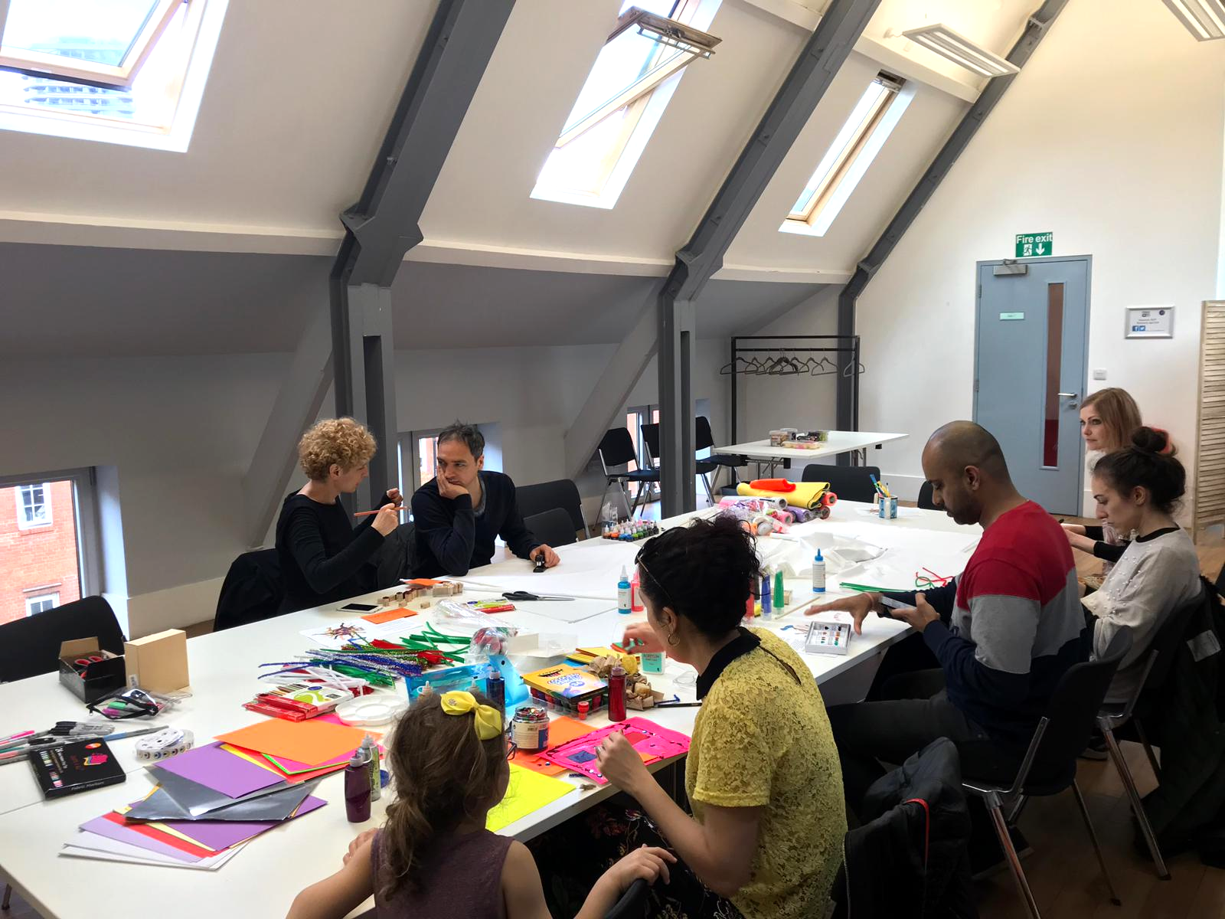

The Role  
To support the implementation of a number of new programmes, we are seeking a skilled and proactive freelance Project Manager to support us over the summer and autumn. This role involves a balanced range of responsibilities and tasks including managing budgets; liaising with clients and maintaining good working relationships; delivering administrative tasks including planning events and co-ordinating with course participants. We are looking for a strong self starter who enjoys both delivering tasks on a fast turnaround as well as representing the organisation and building good relationships with others. This role will work closely with our permanent Programmes Administrator supporting our growing portfolio of Leadership Programmes, largely in conjunction with UK universities.

**About us**

At 64 Million Artists we believe that everyone is creative and that when we are creative we can make positive change in our lives and in the world around us.

**What would the job involve?**

Supporting the Head of Leadership Programmes to smoothly run our academic leadership courses by:

* Being the first point of contact for participants - gathering and communicating all relevant programme information and answering queries.
* Acting as a point of contact for freelance facilitators and coaches, providing them with relevant, timely information to deliver the programme.
* Supporting online and in-person workshops and events - booking rooms/catering, preparing materials, liaising with speakers, managing tech and assisting participants.
* Organising relevant internal and external meetings, and feeding in on administrative matters.
* Booking travel/ accommodation, preparing information for invoicing and managing relevant expenses and receipts.
* Maintaining project momentum, dealing with matters as they arise.
* Feeding into project design and delivery.

**Am I right for the position?**

We are looking for people who:

* Are detail oriented and enjoy being organised
* Are adaptable, proactive and take initiative
* Are aligned with our values
* Have some experience of administration (doesn’t need to be in an arts context)
* Are computer literate and familiar with Microsoft Office and Google Drive
* Have strong communication and interpersonal skills, being an approachable team player who enjoys working in a small team

Skills and experience

We are keen to build a diverse team, so there is no single route you will need to have taken to apply for this role. You may never have worked in a creative company before, though you will have a commitment to our values of care, belonging, courage and curiosity; and be someone that can work autonomously and as part of a team. These skills may have been built in a range of professional roles but also through personal experiences like caring, volunteering or leisure activities.

**Application process**

To apply, please send a short covering email, outlining your approach to work and any experience that might help you excel in the role. If you wish, you could use the above section (**What would the job involve?**) and add bullet points from your own experience that show how you have the relevant skills.

We do not ask for CVs but if you do have a website for your freelance work, a Linkedin profile or links to previous projects, feel free to include these with your covering email. We do ask for the names of 2 referees we can contact if we should proceed to offer you the contract. Please also advise of your availability over the period from now until the end of November and how you would make this role fit in alongside your other commitments.

Covering emails should be sent to [damian@64millionartists.com](mailto:damian@64millionartists.com) and should be received by **5pm Tuesday 9th July**.

If you would be helped by any reasonable adjustments to our application process, please don’t hesitate to contact [Damian@64millionartists.com](mailto:Damian@64millionartists.com)